FOR IMMEDIATE RELEASE: Thursday, April 27, 2017
CONTACT: Damian Fagan, communications manager
541-382-4754 ext. 300, dfagan@highdesertmuseum.org

VINTAGE WORLD WAR II TANK ON EXHIBIT AT THE HIGH DESERT MUSEUM
Tank Day features an American-made Stuart light tank

Bend, OR ~ In conjunction with the High Desert Museum’s exhibition WWII: The High Desert Home Front, an M3A1 Stuart light tank will be on display at the museum for Tank Day, Saturday, April 29.
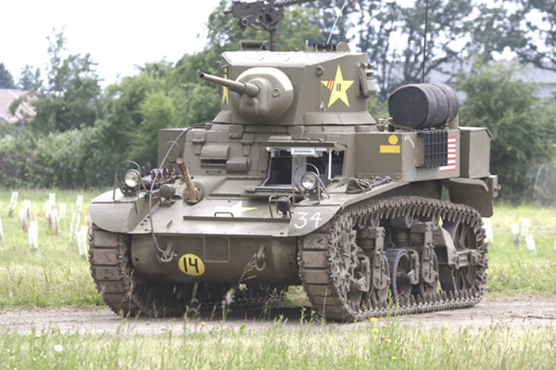
“American-made Stuart tanks were used by British forces prior to the United States’ entry into World War II under the Lend-Lease program,” said the Museum’s Curator of Western History Laura Ferguson. “The first time these tanks saw action with American crews was in 1941 in the Philippines.” The tank is on loan from Steve Greenberg, a private collector from Portland.

Tank Day will run from 10:00 am to 4:00 pm and is free with admission. For more information, visit the Museum’s website: highdesertmuseum.org or call 541-382-4754 ext. 241. WWII: The High Desert Home Front is made possible by Bend Cultural Tourism Fund, The Bulletin, Deschutes Brewery, Horizon Broadcasting Group, Northwest Travel Magazine, Nosler, Oregon Public Broadcasting and Sunriver Resort and with support from Bigfoot Beverages, Central Oregon Radiology Associates, P.C., Century Insurance Group, LLC, Jones & Roth CPAs & Business Advisors, Oregonian Media Group and Summit Bank.

THE HIGH DESERT MUSEUM opened in 1982 and brings regional wildlife, culture, art and natural resources together to promote an understanding of the natural and cultural heritage of North America's high desert country. The Museum uses indoor and outdoor exhibits, wildlife in natural habitats, and living history demonstrations to help people discover and appreciate the high desert environment. The Museum is a 501(c) 3 nonprofit organization accredited by the American Alliance of Museums and is a Smithsonian Affiliate.
###

